**Software Requirement Specification**

**For**

**MyLib**

**Prepared by**

|  |  |
| --- | --- |
| Iman Bin Baharuddin | 192658 |
| Fatin Nabilla binti Muhamad Zaini | 193576 |
| Imran Bin Zakaria | 192659 |
| Muhammad Izwan Bin Suhaime | 193907 |

**TABLE OF CONTENT**

1.0 Introduction 3

1.1 Purpose 3

1.2 Scope 3

1.3 Definitions, Acronyms and Abbreviations 3

1.4 References 4

2.0 Overall Description 5

2.1 User Classes and Characteristics 5

2.2 Operating Environment 5

2.3 Constraints 5

2.4 Assumptions and Dependencies 6

3.0 External Interface Requirements 7

3.1 User Interfaces 7

3.2 Hardware Interfaces 13

3.3 Software Interfaces 13

3.4 Communication Interfaces 13

4.0 Functional Requirements and System Use Case 14

4.1 Functional Requirements 14

4.2 Use Case Diagram 15

4.3 Use Case Description 16

5.0 Non-Functional Requirements 21

6.0 Entity Relationship Diagram 22

# 

# 1.0 Introduction

## 1.1 Purpose

The purpose of MyLib system is to provide a systematic way to manage and store book information. The system will help both students and library staff to keep a constant track of all books in the library. With this system, all work will become much easier as managing books can be done online. Students will be able to view all the lists of books available in the library. The traditional way of managing libraries is much harder to keep track of things and are prone to human errors. These errors can be avoided by using the system to keep track of information systematically and thus it will help in avoiding making mistakes.

## 1.2 Scope

MyLib will be used mainly in institutions such as universities. This system will enable both librarians and students to have direct access to information about books in the library online. This system will help students to check the availability of the books via online. Besides, the librarian can also add new books and update the information about the books. This is seen to be practical compared to manual way. In this documentation students will be referred to as borrowers.

## 1.3 Definitions, Acronyms and Abbreviations

Table 1: Definition of Terms

|  |  |
| --- | --- |
| Term | Definition |
| Borrower | Registered user for borrowing books |
| System | MyLib which helps librarians and students to manage books easily. |
| Librarian | User who works in the library and has additional privilege. |

## 1.4 References

1. Software Requirements Specification IEEE Std 830-1998. <https://ieeexplore.ieee.org/stamp/stamp.jsp?tp=&arnumber=720574&tag=1>

### 

# 2.0 Overall Description

## 2.1 User Classes and Characteristics

Borrower:

* View available books in the library.
* Place a request to borrow a book.
* View library location in Google Maps

Librarian:

* Add new books into the system and delete books.
* Update description about books in the system.
* Manage the borrower of the book whether to approve or reject.

## 2.2 Operating Environment

MyLib is a web-based system. The appropriate web server and browser are required for the development. All the data will be stored in MySQL database management system. Users should be able to access the system using any type of browser such as Google Chrome, Mozilla Firefox, Internet Explorer, Safari etc. The connections to the servers will be based on the criteria of attributes of the user like his/her location and server will be working whole 24/7.

## 2.3 Constraints

The constraints in design and implementation phase are as follows:

* Language requirement: This system only caters in English.
* Browser support limitations: This system is a web-based application. There is an issue of an unsupported browser problem.
* Security consideration: All users will have their own username and password.

## 2.4 Assumptions and Dependencies

* The system does require database server MySQL for storing the username and password for different types of user of the system.
* The system also assumes that details regarding each customer would be made correctly.
* The end users of this software are assumed to have a basic level of computer knowledge i.e. point and click.
* Users must have basic knowledge of English.
* The third-party component that we integrated in the MyLib system is Google Maps. It enables borrowers and librarians to see the actual location of the library.

# 3.0 External Interface Requirements

### 3.1 User Interfaces

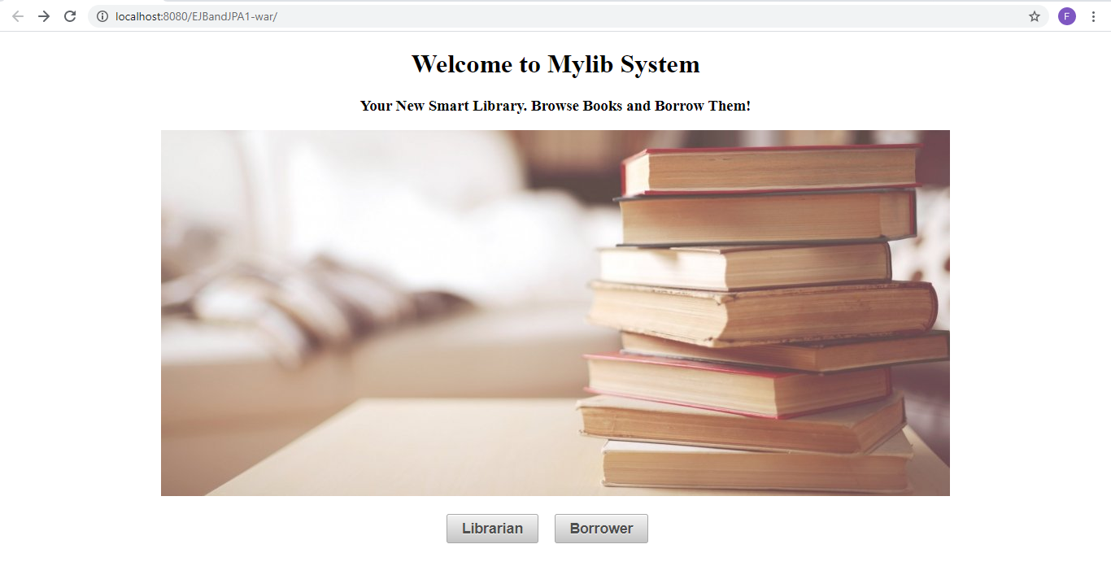

Figure 3.1.1 Main Page of MyLib

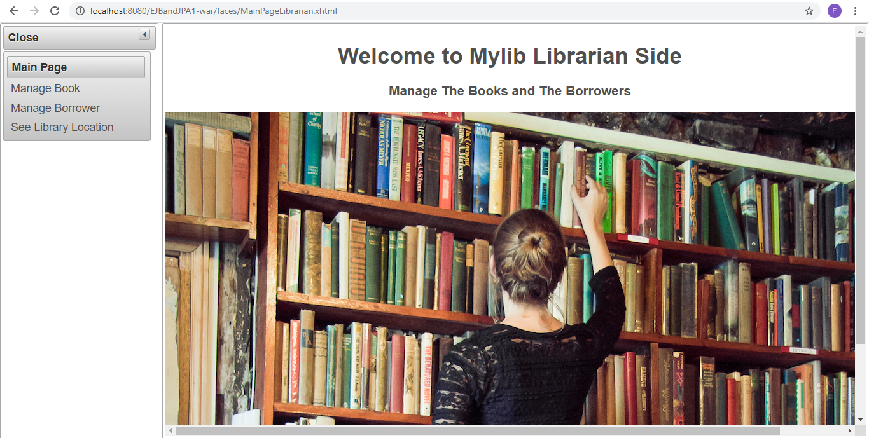

Figure 3.1.2 Main Page Librarian (Librarian)

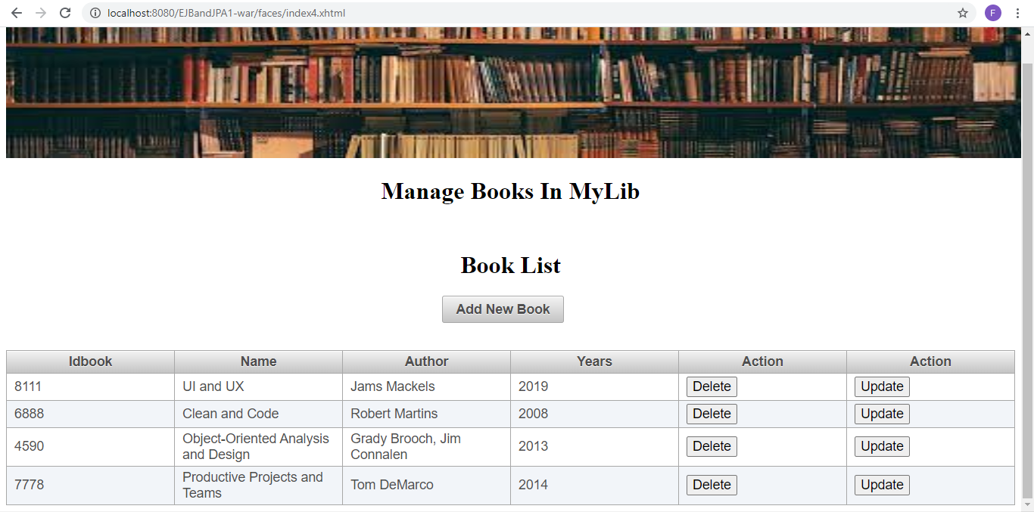

Figure 3.1.3 Manage Books View (Librarian)

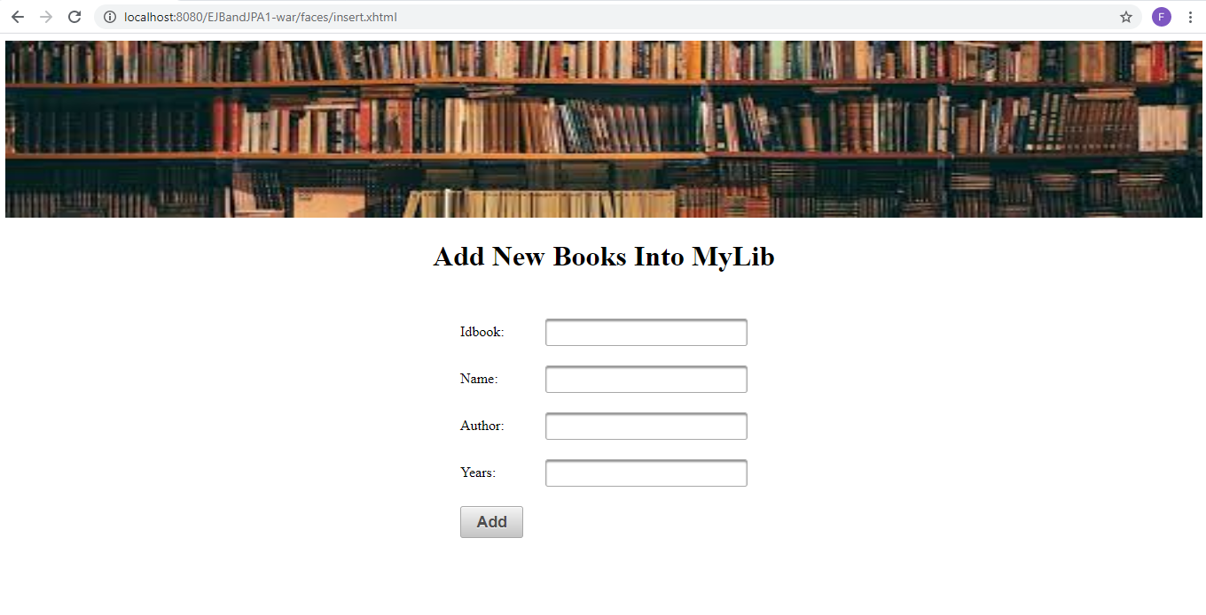

Figure 3.1.4 Add New Book (Librarian)

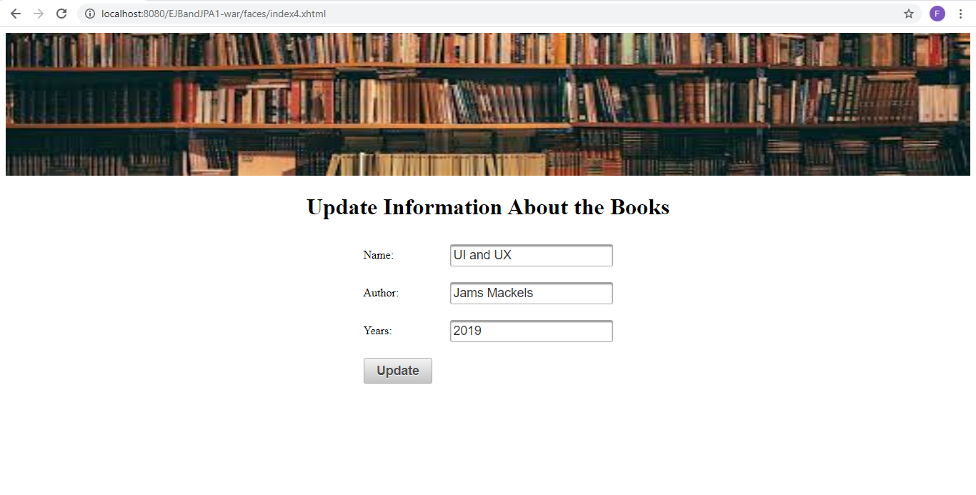

Figure 3.1.5 Manage Books Info and Update (Librarian)

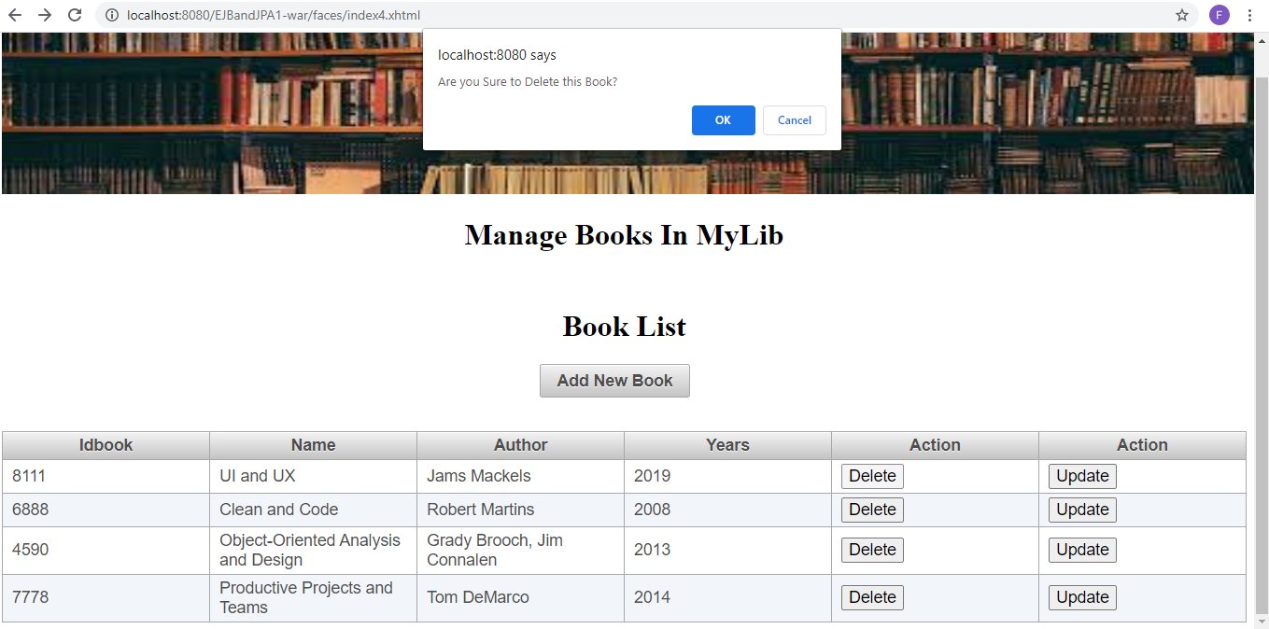

Figure 3.1.6 Delete Book (Librarian)

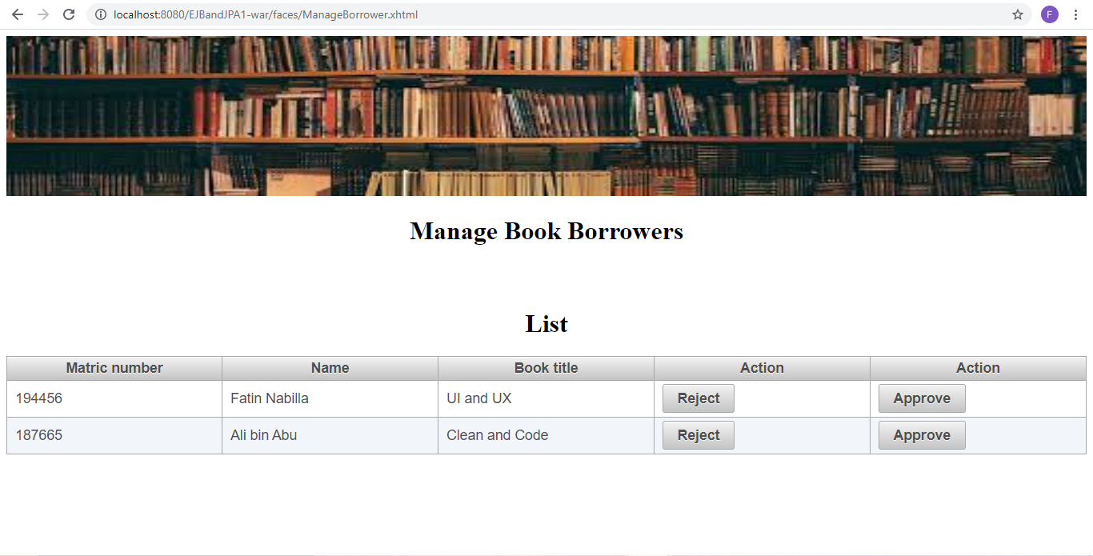

Figure 3.1.7 Manage Book Borrower (Librarian)

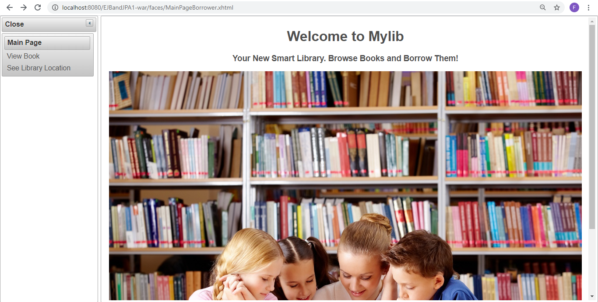

Figure 3.1.8: Main Page Borrower (Borrower)

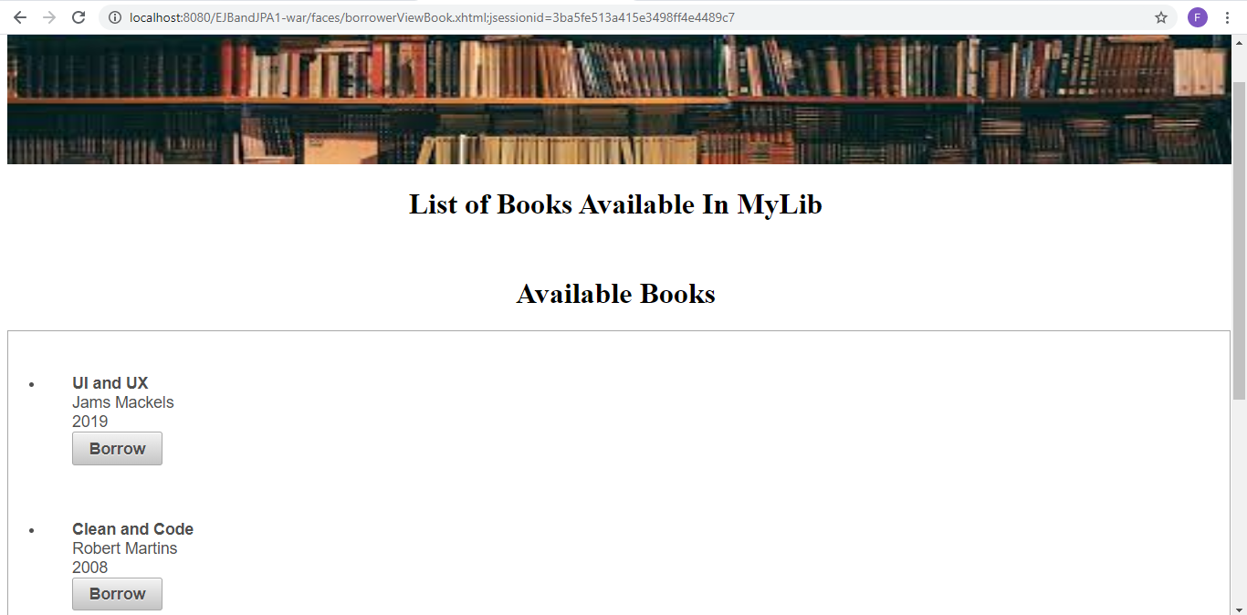

Figure 3.1.9 View Books Available (Borrower)

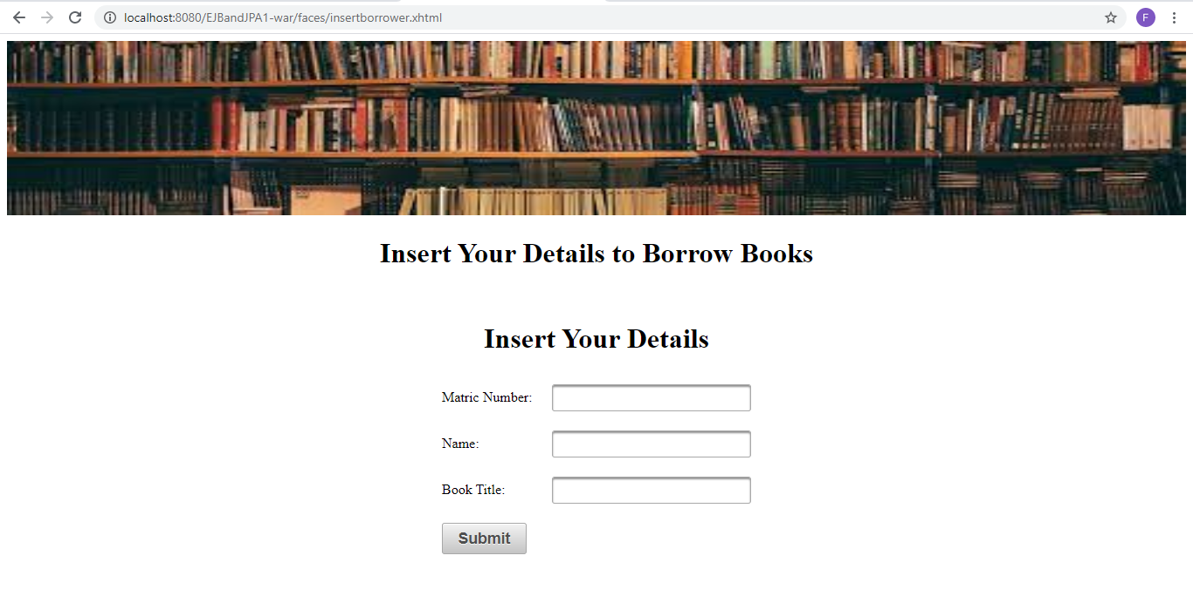

Figure 3.1.10 Borrow Book (Borrower)

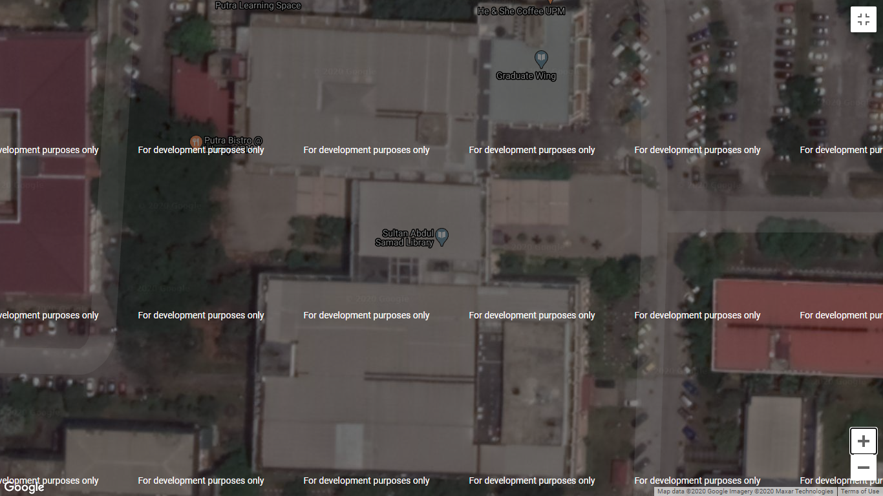

Figure 3.1.11 View Library Location (Borrower & Librarian)

### 3.2 Hardware Interfaces

Hardware requirements for MyLib on internet will be same for both the parties which are follows:

* Processor: Pentium 1 or above.
* RAM: 128MB or above.
* HD: 20GB or above.

### 3.3 Software Interfaces

* Operating System: Windows.
* Development Tool: NetBeans, Primefaces, JavaServer Faces
* Database: MySQL (PhpMyAdmin).

### 3.4 Communication Interfaces

* MyLib system shall notify the borrower to pick up the book that they had requested to borrow.
* A list of books available will be displayed to the students when they request to view it.

# 4.0 Functional Requirements and System Use Case

## 4.1 Functional Requirements

Table 2: Functional Requirement

|  |  |  |  |
| --- | --- | --- | --- |
| Use Case ID | Use Case | Description | Actors Involved |
| SRS_REQ_001 | Add Book | Librarians add new books into the MyLib system. | Librarian |
| SRS_REQ_002 | View list of books | View the list of available books in the system’s database. | Librarian, Borrower |
| SRS_REQ_003 | Borrow Request | Borrower can request to borrow books | Borrower |
| SRS_REQ_004 | View Book | View book descriptions | Librarian, Borrower |
| SRS_REQ_005 | Manage Borrower | Librarian will able to approve and reject borrower book request | Librarian |
| SRS_REQ_006 | Manage Book Info | Manage the book’s information | Librarian |
| SRS_REQ_007 | Remove Book | Librarians remove books from the available book list. | Librarian |

## 4.2 Use Case Diagram

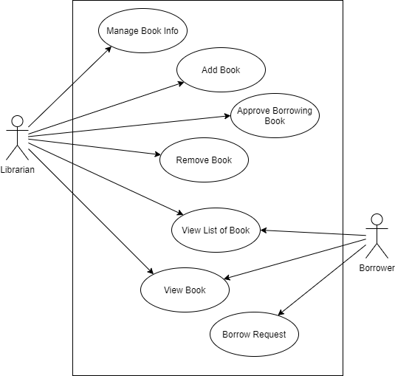

Figure 4.2: Use Case Diagram for MyLib system

## 4.3 Use Case Description

Table 3: Use Case 1: Add Book

|  |  |
| --- | --- |
| Identifier | SRS_REQ_001 |
| Name | Add Book |
| Objective | Librarians add new books into the MyLib system |
| Priority | High |
| Actor | Librarian |
| Pre-condition(s) | 1. Sign in as librarian 2. Librarian click register book button |
| Flow of Event | **Basic Flow**   1. Book id is given by continuing from the previous book id. 2. The librarian enters information about the book including the title, barcode, author etc. 3. Click register book button 4. The system displays successful message |
| Alternative Flow | 3. a) Invalid input or incomplete information entered. Back to step 2. |
| Post-condition(s) | Book detail and information is registered into the system database |

Table 4: Use Case 2: View list of books

|  |  |
| --- | --- |
| Identifier | SRS_REQ_002 |
| Name | View list of book |
| Objective | View list of available books in the system’s database. |
| Priority | High |
| Actor | Librarian, Borrower |
| Pre-condition(s) | No pre-condition |
| Flow of Event | **Basic Flow**   1. The actors click on the View List of Book Button in the Homepage. 2. The system will display the list of all available book in the library database 3. The information of the book will be shown such as book id, author name, date published etc. |
| Post-condition(s) | The librarian and borrower will be able to view the list of books successfully. |

Table 5: Use Case 3: Borrow request

|  |  |
| --- | --- |
| Identifier | SRS_REQ_003 |
| Name | Borrow request |
| Objective | Borrower can request to borrow books |
| Priority | High |
| Actor | Borrower |
| Pre-condition(s) | Click on borrow button |
| Flow of Event | **Basic Flow**   1. The borrower clicks on the borrow button. 2. The borrower enters their matrix number, borrower name and book name. 3. Click the borrow button. 4. Librarian can approve the borrower’s request |
| Alternative Flow | 4. a) Librarian can reject borrower’s request |
| Post-condition(s) | The user will be redirect to their respective page |

Table 6: Use Case 4: View Book

|  |  |
| --- | --- |
| Identifier | SRS_REQ_004 |
| Name | View Book |
| Objective | View the book descriptions. |
| Priority | Medium |
| Actor | Librarian, Borrower |
| Pre-condition(s) | 1. Use case 2 is used 2. List of books is displayed |
| Flow of Event | **Basic Event**   1. The user clicks on the book title 2. The system will display the information of the book from the database. 3. Information such as title, barcode, author, book’s location, status etc. |
| Post-condition(s) | Book description is displayed |

Table 7: Use Case 5: Approve Borrowing Book

|  |  |
| --- | --- |
| Identifier | SRS_REQ_005 |
| Name | Approve Borrowing Book |
| Objective | Librarian will able to approve and reject borrower book request |
| Priority | High |
| Actor | Librarian |
| Pre-condition(s) | 1. Borrower information is already in the database 2. Sign in as librarian 3. Book is available in the database |
| Flow of Event | **Basic Event**   1. Librarian click on the manage borrower button 2. Librarian click on the approve button 3. Borrower request status will become approved. 4. System will display the return date of the book |
| Alternative Flow | 2. a) Librarian click on the reject button  3. a) Borrower request status will become rejected. |
| Post-condition(s) | Date for return book is created |

Table 8: Use Case 6: Manage Book Info

|  |  |
| --- | --- |
| Identifier | SRS_REQ_006 |
| Name | Manage Book Info |
| Objective | Manage the book’s information. |
| Priority | Medium |
| Actor | Librarian |
| Pre-condition(s) | 1. Logged in as librarian 2. Book is in the database 3. Use case 4 is used |
| Flow of Event | **Basic Event**   1. The librarian clicks the manage book button on the menu bar 2. The librarian clicks on the update button on the book that wanted to be updated. 3. The librarian enters new information of the book 4. The librarian clicks the “Save” button. 5. The system shows an update message. |
| Alternative Flow | 3. a) The librarian clicks the cancel button. Update made to the book is  cancel |
| Post-condition(s) | Book information updated |

Table 9: Use Case 7: Remove Book

|  |  |
| --- | --- |
| Identifier | SRS_REQ_007 |
| Name | Remove Book |
| Objective | Borrower remove book from available list in the database. |
| Priority | High |
| Actor | Librarian |
| Pre-condition(s) | 1. Logged in as librarian 2. Book is in the database 3. Use case 4 is used |
| Flow of Event | **Basic Flow**   1. The librarian clicks on manage book button on the menu bar 2. Then, the system display manages books page 3. The librarian clicks on the delete button. 4. The system display confirmation page 5. If the librarian clicks on the confirm, the book will remove from the database |
| Alternative Flow | 5.a) If the librarian clicks the cancel button, the book will not be  removed. |
| Post-condition(s) | The book will be deleted from the database |

# 5.0 Non-Functional Requirements

Table 10: Non-Functional Requirement

|  |  |  |  |  |
| --- | --- | --- | --- | --- |
| **QA ID** | **Quality Attributes** | **Attribute Refinement** | **ASR ID** | **Architecture Significant Requirement (ASR)** |
| **1** | Performance | Response Time | 1.1 | Our Application will be interactive, and the delays involved will be less, so in every action-response of the application, there are no immediate delays and will be complete in less than 5 second. |
| **2** | Reliability | Connection | 2.1 | The system will be able to operate and be accessed by multiple users even when it is flooded with requests or if one of the servers is down. There will be a backup server to make sure the system is always connected. |
| **3** | Security | Confidentiality | 3.1 | The system will use define user type in database to authorize in order to grant them the privilege and access to the application |
| Integrity | 3.2 | The system will resist unauthorized access and report the attempts |
| **4** | Availability | No downtime | 4.1 | Our system is accessible and available from 7.30a.m. until 11.00p.m. since that is 30 minutes before and after closing hour |

# 6.0 Entity Relationship Diagram

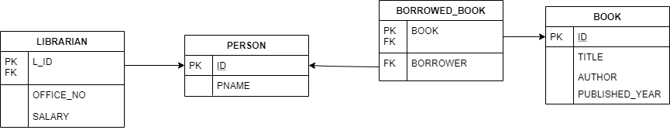

Figure 6: Entity Relationship Diagram